
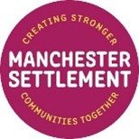

Long Term Conditions
North Manchester Project-
A Partnership Opportunity

Overview
Funded until 31 March 2027 by the Manchester Local Care Organisation, Manchester Settlement seeks a partnership with four voluntary community and social enterprise organisations (Neighbourhood Health Creation Organisations); one in each of the areas of North Manchester listed below, to help roll out a new Community Health Creation Project. Each organisation will be funded to employ/deploy a co-ordinator (Neighbourhood Health Creating Co-ordinator) to support project delivery.
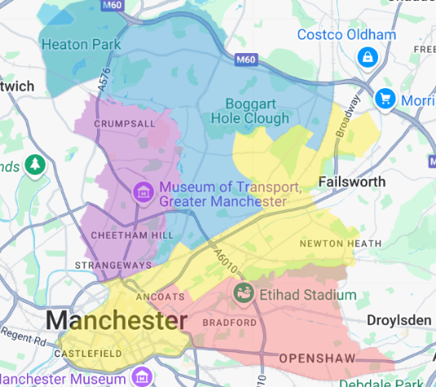

- Cheetham and Crumpsall
- Higher Blackley, Harpurhey and Charlestown
- Miles Platting, Newton Heath and Moston & City Centre
- Ancoats, Beswick, Clayton and Openshaw

Map of 4 project areas

We invite VCSE organisations to submit expressions of interest to become one of the four Neighbourhood Health Creation Organisation’s (NHCO’s) in the ‘Ancoats, Beswick, Clayton and Openshaw’ neighbourhood and the successful organisation will join Manchester Settlement to deliver the project. Each organisation will manage a budget of £32,000 per year needed to:
- employ a Neighbourhood Health Creating Co-ordinator* (see notes on Employment Model)
- create sub-networks of Health Creating VCSE Organisations and Health Creator’s
- provide learning bursaries to these organisations
- manage an activity grants pot and budgets for resources, volunteer expenses and activity delivery
- embed the Health Creation Framework https://thehealthcreationalliance.org/health-creation/
*Notes on Employment Models
As the Lead Organisation for the area, you will be expected to nominate or appoint a Neighbourhood Health Creation Co-ordinator working 15 hours per week (or variants of this). As such your organisation should have sufficient employment practices/insurances to support employment.
Where good employment practice cannot be demonstrated it may be possible for Manchester Settlement to be the employer of the individual, deploying / seconding them to work with your organisation under Manchester Settlement Policies. In this case recruitment and selection would be conducted in partnership with the Local Lead Organisation, with overall decision-making resting with Manchester Settlement.
Project Aims

This project will enable targeted communities with long term health conditions to take control of their own health by embracing the existing relationships, trust and connectivity that underpin the work of key VCSE community organisations to meet the following aims:-

- To improve awareness of and management of long term health conditions (LTC’s)
- Develop and implement activity across 4 priority areas across North Manchester
- Embed ‘The Health Creation Framework’ in all processes

Project Structure

Manchester Settlement as the lead organisation will oversee the project working with four NHCO’s who will each recruit four VCSE organisations to deliver the project to their communities, within their neighbourhood.
The VCSE organisations will recruit volunteers who will be trained and recognised as ‘Health Creators’ to support in project delivery.
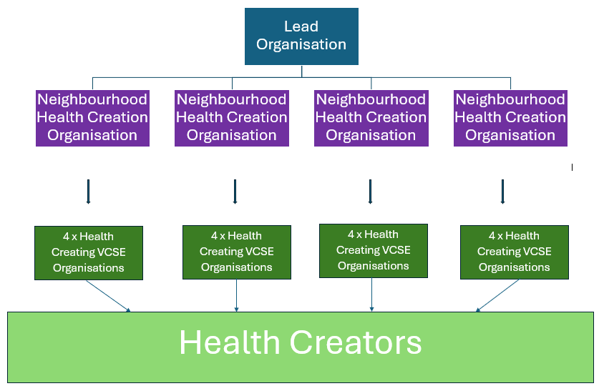

Key Features of the Model
- Neighbourhood Health Creation Organisations (NHCO) – identified organisations in relevant neighbourhoods which will manage the community projects deploying a Neighbourhood Health Creation Co-ordinator. These organisations will enter into partnership with Manchester Settlement.
- Neighbourhood Health Creating Co-ordinators (NHCC) - employed/deployed by local Neighbourhood Health Creation Organisation’s to work with other local Health Creating VCSE Organisations and communities to help to increase the Health Creation infrastructure. They will help to do this by supporting the development of Health Creators who will have tasks to manage as part of the project plan.

- Health Creating VCSE Organisations (HCVO’s) – small community organisations that will benefit from packages of training, support and small grants issued by the NHCO and their NHCC.

- Health Creators – individual community members who, having taken part in Health Creation Activities led by HCVO’s or others are given the skills, knowledge and networks to be considered as Health Creators.

Delivery Methods
- Training, Development and Capacity Building Programme – health equity courses, health creation course, including supervision elements for Health Creating VCSE Organisations
- A co-produced ‘Marketing Campaign’ that makes the most of local trusted people and places
- Health Creation ethos implemented for delivery of project – environment created that is based on positive relationships incorporating values of trust and respect
- Evaluation Framework agreed between Lead Organisation, NHCO’s and NHCC’s
- Reflection embedded to adapt and change interventions if/when appropriate

Eligibility Criteria for Neighbourhood Health Creation Organisations

Essential Criteria for Potential Partner
- organisational capacity to lead project until 31st March 2027
- is well known within the selected Neighbourhood with strong community links
- significant history of project delivery in the Neighbourhood selected
- desire and ability to engage in an Action Learning model
- experience delivering health creating activities
- confidence that the organisation will have complimentary programmes of community engagement that will run alongside this programme for the duration of the project
Experience
- previous engagement with communities where Long Term Health Conditions are prevalent
- experience of managing volunteers
- experience of line managing a staff member
- experience of delivering health projects and or health-based workshops/sessions
- experience of project and financial management
- experience of partnership working with organisations
Knowledge
- understanding of health inequalities affecting communities
- basic knowledge of project evaluation and monitoring

Funding available
- This opportunity has a fixed value of £32000 for each year of the project, of which £8000 each year is for distribution to other local groups.
- A new laptop with appropriate software and a number of tablet devices can be supplied to each project on long term loan basis where this is useful.
 | Yr 1 | Yr2 | Notes
Delivery Partner Fee | £15,000 | £15,000 | Partner fee for all employment and management costs of Co-ordinator min 12 hours pw
Learning Bursaries | £8,000 | £8,000 | Funds available for distribution to other groups to support engagement in HC learning and networking
Activity Grants Pot | £8,000 | £8,000 | Funds available for distribution to other groups for activities that put HC principles into practice
Resources | £500 | £500 | To use monies as required
Volunteer expenses | £500 | £500
 | £32,000 | £32,000

Detailed Roles and Responsibilities*

Overall Project Leadership – Manchester Settlement
- Project management role across the programme and all four neighbourhoods
- Project steering board - Design, launch and coordination
- Delivery of training & ongoing mentoring to Neighbourhood Health Creating Co-ordinators to include understanding of the model and train the trainer.
- Production and maintenance of online Health Creation membership platform
- Building and maintaining cross project culture, sharing practice etc through meetings and events

Neighbourhood Health Creation Organisations - Roles and Responsibilities
- Ensure appointment of Neighbourhood Health Creating Co-ordinator
- To fully engage in a Health Creation learning and development programme led by the overall Project Manager (dependent upon your existing knowledge and experience)
- To fully engage in a programme of skills training around training and mentoring of individuals and organisations
- To join the Project Manager in decision making panels to allocate funds to micro-community organisations from a Local Wellbeing Fund
- To lead the collection of data in your area through supporting with project wide data systems
- To support area specific and North Manchester wide networking and connectivity in a variety of formats, including the Health Creation Online Platform
- To engage in meetings and events for peer learning and information sharing
- To ensure that NHCC is scheduled to be able to attend monthly learning events (days to be agreed)
- To recruit four VCSE organisations for the LTC’s project in the neighbourhood
*See Appendix 1 for Neighbourhood Health Creating Co-ordinator Role - Key functions and example specification and Health Creator role description.

Accountability Framework
North Manchester Health and Wellbeing Steering Group -Manchester Settlement to report to on a monthly basis
North Manchester Health Creation Local Steering Group – Lead organisation to co-ordinate and feedback project progress
- NHCC’s to attend on a quarterly basis

Monitoring and Evaluation
This project is an Action Learning Project. Partner organisations will be funded to have the time to engage in significant training and evaluation activity. Evaluation tools will be co-designed with partners. An online Partner Platform will be used to contain documentation and to roll out evaluation and monitoring tools.

Planned Impact
Neighbourhood Health Creation Organisation - Knowledge, Skill and Capacity (LTC’s = diabetes, asthma, arthritis, epilepsy, chronic fatigue, and high blood pressure)
Knowledge
- Increased knowledge in specific LTC (see above) as NHCO establishes as a specialist hub for sharing good practice/knowledge/experience between HCVO participating in the project
- The Framework for Health Creation embedded via a ‘Health Creation’ policy or in vision/mission statement which is shared with employees (and where appropriate with volunteers/health creators).
Health Creating VCSE Organisation - Knowledge, Skill and capacity (LTC’s = diabetes, asthma, arthritis, epilepsy, chronic fatigue, and high blood pressure)
- An increase in patients being signposted to relevant services (as HCVO will have increased knowledge in the services and pathways available for patients with LTC’s.
- Increase in partnership working - HCVO’s will develop knowledge of relevant partners (including clinical) to seek health information and advice (stronger partnerships between community organisation, leaders, and residents).
- NHCO’s and HCVO’s understanding of ‘The Framework for Health Creation’ increased.
- NHCO’s and HCVO’s managers/CEO’s will have a good understanding of health inequalities and health equity in relation to LTC’s
- NHCO’s and HCVO’s will have good knowledge of community engagement practice supported by The Framework for Health Creation
- NHCO’s and HCVO’s to have increased understanding of the ‘causes’ of ill-health in their communities related to LTC’s.
- NHCO’s and HCVO’s to develop evaluation knowledge related to the Health Creation Framework

Skills
- Improved ‘good community engagement’ techniques by embedding the Framework for Health Creation
- Improved co-production techniques - Successful integration of community feedback into project planning and decision-making
- Increase in partnership development skills via trusting relationships between Neighbourhood Health Creation Organisations and Health Creating VCSE Organisations
- Facilitation skills to increase community engagement with Health Creating VCSE Organisations

On Primary Care
- Increased support and infrastructure within community and VCSE for signposting via social prescribers
- LTC conditions prevention and management of existing conditions for patients
- Increased diagnosis / readings / uptake of services
- Increased uptake on relevant QOF registers
- Strengthen existing PCN/Neighbourhood relations
- Identifying patients early - potential decrease in acute presents on the day in General Practice
- Support networks signposted to patients directly
- More effective patient appointments - Increase in patient’s knowledge in LTC’s to impact on GP time in appointment
- Reduced unnecessary GP appointments for LTC’s management
- On Secondary Care
- Support for people with LTC management
- Early support and Primary Care intervention - possible decrease in acute attendees at urgent and on the day care facilities
- Early diagnosis and prevention will aid pressures in bed management
- Positive support for people on long waiting lists
- Signposting into better supported VCSE organisations for outpatients
- Increases reach into areas with poor health outcomes and improves health access and uptake of screening and diagnostic services

Appendix 1 – ‘Other’ Roles and responsibilities

a) Local Leadership – Neighbourhood Health Creating Co-ordinator – Key Role functions
- Participation in learning activities to understand what health creation is and to become proficient in using the framework (awareness raising about the model, measurement of existing work using the health creation self-assessment tool, learning how to redesign delivery to enhance health creating potential)
- Participation in ongoing action learning to continue to develop and build on health creating activities and embed this within practice.
- Creation and maintenance of own action plans
- - Leadership and delivery of neighbourhood engagement and communication around health creation
- Neighbourhood delivery of training sessions, mentoring sessions, action learning meetings.
- Supporting Health Creating VCSE Organisations in the development of their individual delivery plans
- Joint management with Project manager of neighbourhood grant funds
- Provision of support and guidance to the neighbourhood health creators, including provision of 1:1 support with organisations and individuals, practical ‘check-in’s’
- Coordination of health creators across the neighbourhood in order for them to be able to respond to emergent priorities in partnership with others across the system
- Gathering of evaluation insight from neighbourhood health creators
- Delivery against individual action plans
- Attendance at meetings hosted by lead organisation
- Raising profile of main and individual project - on own social media

b) Neighbourhood Health Creating Co-ordinator – Example Role Specification
The ideal candidate for this role will be someone who…
- is passionate about improving community health
- values volunteers
- has good knowledge of and working with the voluntary sector and volunteers
- understands the value of community engagement to improve health outcomes
- is a good listener, patient and has a nurturing and caring nature
- values partnership working
- has excellent organisation and time management skills
- has knowledge and understanding of equal opportunities
- has a good understanding of the different communities that live and work in North Manchester
is able to…
- develop good working relationships with partner organisations and volunteers
- manage project plans (meet deadlines and adapt if/when necessary)
- conduct talks to community groups
- provide feedback regarding project outcomes (method decided by project manager)
- manage and produce expenditure data/reports
- use social media i.e. WhatsApp, Instagram
- produce resources i.e. leaflets, posters, information documents
has experience of…
- managing projects
- delivering talks/sessions to community groups
- working with volunteers
- working in partnership with organisations
Meets the following essential criteria…
- able to demonstrate good communication skills (verbal and written)
- able to use Microsoft computer packages and other software i.e. Microsoft Word, PowerPoint as a minimum
- able to interact with adults and children of all ages
- has good spoken and written English
- able to work as part of a team
- able to demonstrate an excellent work ethic
- able to commit to learning and development opportunities
Desirable
- Ability to communicate in languages other than English

c) Health Creators
A Health Creator is anyone that can support the process of Health Creation through which individuals and communities gain a sense of purpose, hope, mastery and control over their lives and environments: When this happens individual and community health and wellbeing is enhanced.

